Báo cáo Thực hành lập trình hướng đối tượng

Họ và tên : Lê Thành Đạt

Mssv : 20225804

**Bài 2.2.1:** Write, compile the first Java application:

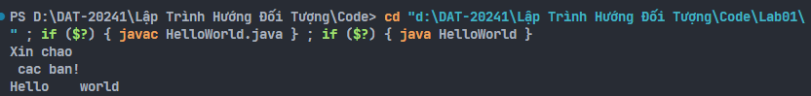

**Bài 2.2.2:** Write, compile the first dialog Java program

**Bài 2.2.3:** Write, compile the first input dialog Java application

**Bài 2.2.4:** Write, compile, and run the following example

**Bài 2.2.5:** Write a program to calculate sum, difference, product, and quotient of 2 double numbers which are entered by users.

**Bài 2.2.6:** Write a program to solve:

**The first-degree equation (linear equation) with one variable**

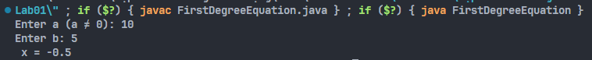

**The system of first-degree equations (linear system) with two variables**

**The second-degree equation with one variable**

**Bài 6.1 :** Write, compile and run the ChoosingOption program:

Note: We use JavaBasics project for this exercise.

**Bài 6.2 :** Write a program for input/output from keyboard

Note: We use the JavaBasics project for this exercise.

**Bài 6.3 :** Write a program to display a triangle with a height of n stars (*), n is entered by users.

**Bài 6.4 :** Write a program to display the number of days of a month, which is entered by users (both month and year). If it is an invalid month/year, ask the user to enter again.

Note: You must create a new Java project for this exercise.

* The user can either enter a month in its full name, abbreviation, in 3 letters, or in number.
* To illustrate, the valid inputs of January are January, Jan, Jan, and 1.
* The user must enter a year in a non-negative number and enter all the digits. For instance, the valid inputs of year 1999 is only 1999, but not 99, “one thousand nine hundred ninety-nine”, or anything else.
* A year is either a common year of 365 days or a leap year of 366 days. Every year that is divisible by 4 is a leap year, except for years that are divisible by 100, but not by 400. For instance, year 1800 is not a leap year, yet year 2000 is a leap year. In a year, there are twelve months, which are listed in order as follows.

**Bài 6.5:** Write a Java program to sort a numeric array, and calculate the sum and average value of array elements.

Note: You must create a new Java project for this exercise.

* The array can be entered by the user or a constant.

**Bài 6.6 :** Write a Java program to add two matrices of the same size.

Note: You must create a new Java project for this exercise.

- The matrices can be entered by the user or constants.

